**Name: Sanika Mehetre**

**Div: D15B**

**Roll No: 34**

**Experiment No.8**

**Aim:** Create a Jenkins CICD Pipeline with SonarQube / GitLab Integration to perform a static analysis of the code to detect bugs, code smells, and security vulnerabilities on a sample Web / Java / Python application.

**Theory:**

**What is SAST?**

Static application security testing (SAST), or static analysis, is a testing methodology that analyzes source code to find security vulnerabilities that make your organization’s applications susceptible to attack. SAST scans an application before the code is compiled. It’s also known as white box testing.

**What problems does SAST solve?**

SAST takes place very early in the software development life cycle (SDLC) as it does not require a working application and can take place without code being executed. It helps developers identify vulnerabilities in the initial stages of development and quickly resolve issues without breaking builds or passing on vulnerabilities to the final release of the application.

SAST tools give developers real-time feedback as they code, helping them fix issues before they pass the code to the next phase of the SDLC. This prevents security-related issues from being considered an afterthought. SAST tools also provide graphical representations of the issues found, from source to sink. These help you navigate the code easier. Some tools point out the exact location of vulnerabilities and highlight the risky code. Tools can also provide in-depth guidance on how to fix issues and the best place in the code to fix them, without requiring deep security domain expertise.

It’s important to note that SAST tools must be run on the application on a regular basis, such as during daily/monthly builds, every time code is checked in, or during a code release.

**Why is SAST important?**

Developers dramatically outnumber security staff. It can be challenging for an organization to find the resources to perform code reviews on even a fraction of its applications. A key strength of SAST tools is the ability to analyze 100% of the codebase. Additionally, they are much faster than manual secure code reviews performed by humans. These tools can scan millions of lines of code in a matter of minutes. SAST tools automatically identify critical vulnerabilities—such as buffer overflows, SQL injection, cross-site scripting, and others—with high confidence.

**What is a CI/CD Pipeline?**

CI/CD pipeline refers to the Continuous Integration/Continuous Delivery pipeline. Before we dive deep into this segment, let's first understand what is meant by the term ‘pipeline’?

A pipeline is a concept that introduces a series of events or tasks that are connected in a sequence to make quick software releases. For example, there is a task, that task has got five different stages, and each stage has got some steps. All the steps in phase one have to be completed, to mark the latter stage to be complete.

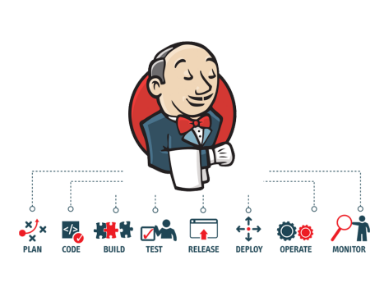Now, consider the CI/CD pipeline as the backbone of the DevOps approach. This Pipeline is responsible for building codes, running tests, and deploying new software versions. The Pipeline executes the job in a defined manner by first coding it and then structuring it inside several

blocks that may include several steps or tasks.

**What is SonarQube?**

SonarQube is an open-source platform developed by SonarSource for continuous inspection of code quality. Sonar does static code analysis, which provides a detailed report of bugs, code smells, vulnerabilities, code duplications.

It supports 25+ major programming languages through built-in rulesets and can also be extended with various plugins.

**Benefits of SonarQube**

● **Sustainability -** Reduces complexity, possible vulnerabilities, and code duplications, optimising the life of applications.

● **Increase productivity -** Reduces the scale, cost of maintenance, and risk of the application; as such, it removes the need to spend more time changing the code

● **Quality code -** Code quality control is an inseparable part of the process of software development.

● **Detect Errors -** Detects errors in the code and alerts developers to fix them automatically before submitting them for output.

● **Increase consistency -** Determines where the code criteria are breached and enhances the quality

● **Business scaling -** No restriction on the number of projects to be evaluated

● **Enhance developer skills -** Regular feedback on quality problems helps developers to improve their coding skills

**Integrating Jenkins with SonarQube:**

**Prerequisites:**

● Jenkins installed

● Docker Installed (for SonarQube)

● SonarQube Docker Image

**Steps to create a Jenkins CI/CD Pipeline and use SonarQube to perform SAST**

1. Open up Jenkins Dashboard on localhost, port 8080 or whichever port it is at for you.

2. Run SonarQube in a Docker container using this command -

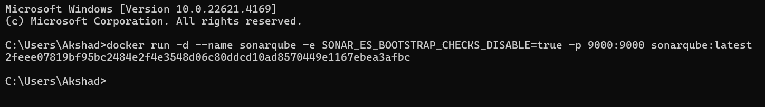



3. Once the container is up and running, you can check the status of SonarQube at localhost port 9000.

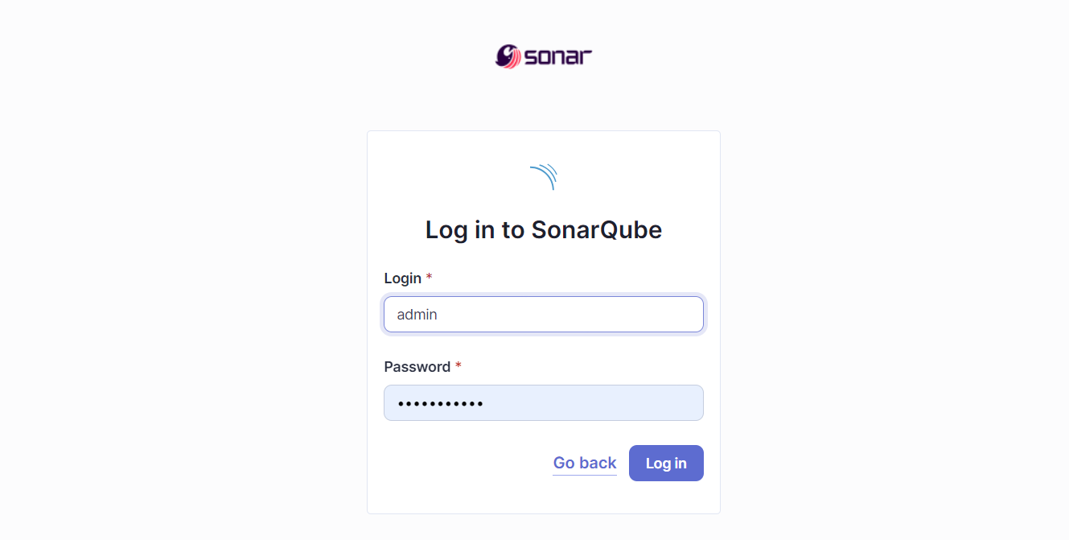4. Login to SonarQube using username *admin* and password *admin*.

5. Create a manual project in SonarQube with the name **sonarqube-test** 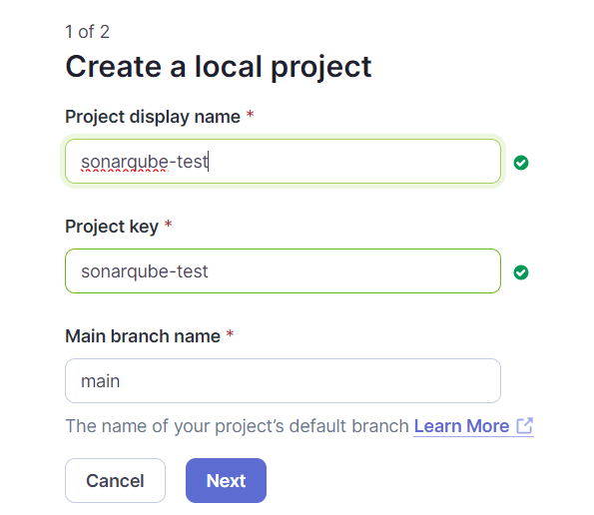

Setup the project and come back to Jenkins Dashboard.

6. Create a New Item in Jenkins, choose **Pipeline**.

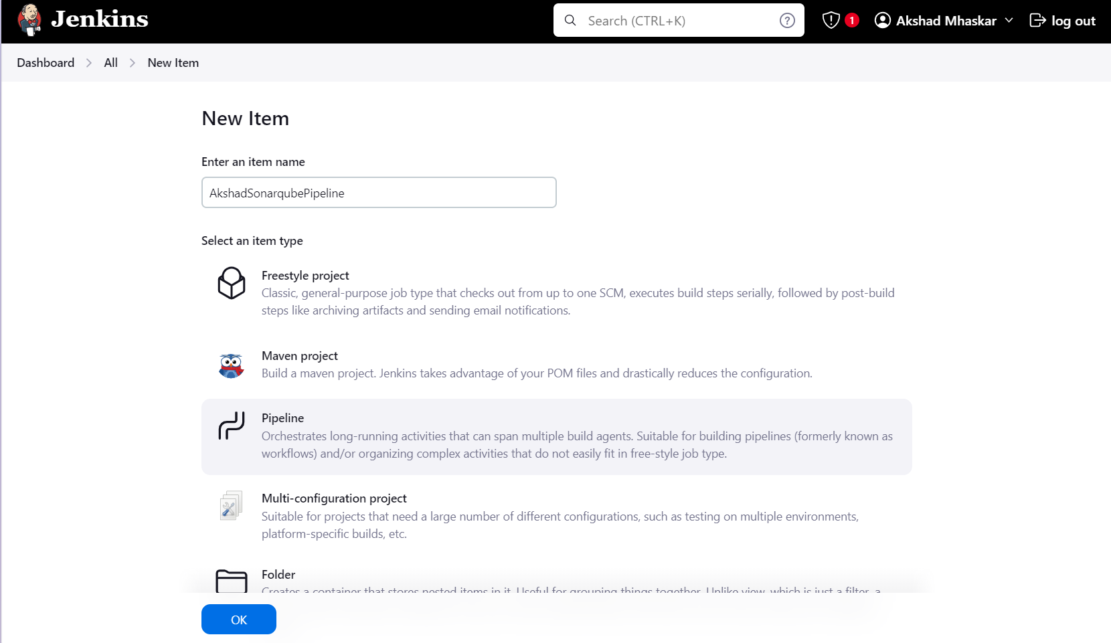

7. Under Pipeline Script, enter the following -

pipeline {

agent any

stages {

stage('SonarQube Analysis') {

steps {

script {

bat "\"C:\\Program Files\\sonar-scanner-6.2.0.4584-windows-x64\\bin\\sonar-scanner.bat\" " +

"-D sonar.login=admin " +

"-D sonar.password=pass1 " +

"-D sonar.projectKey=sonarqube-test " +

"-D sonar.exclusions=vendor/**,resources/**,**/*.java " +

"-D sonar.host.url=http://127.0.0.1:9000/"

}

}

}

}

}

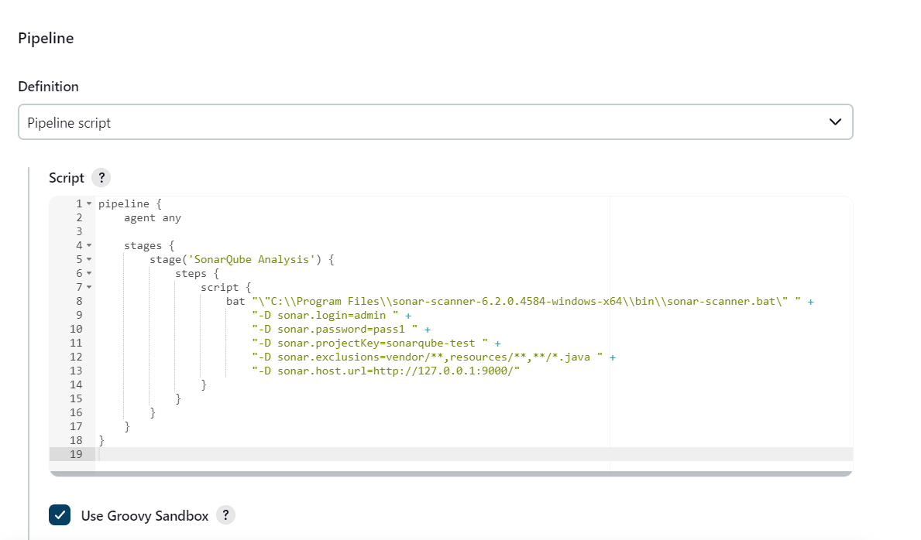

It is a java sample project which has a lot of repetitions and issues that will be detected by SonarQube.

8. Run The Build.

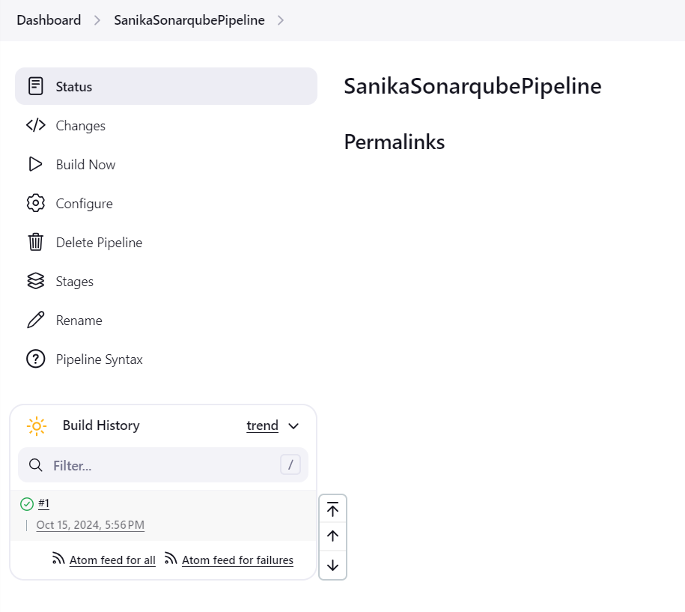

9. Check the console output once the build is complete.

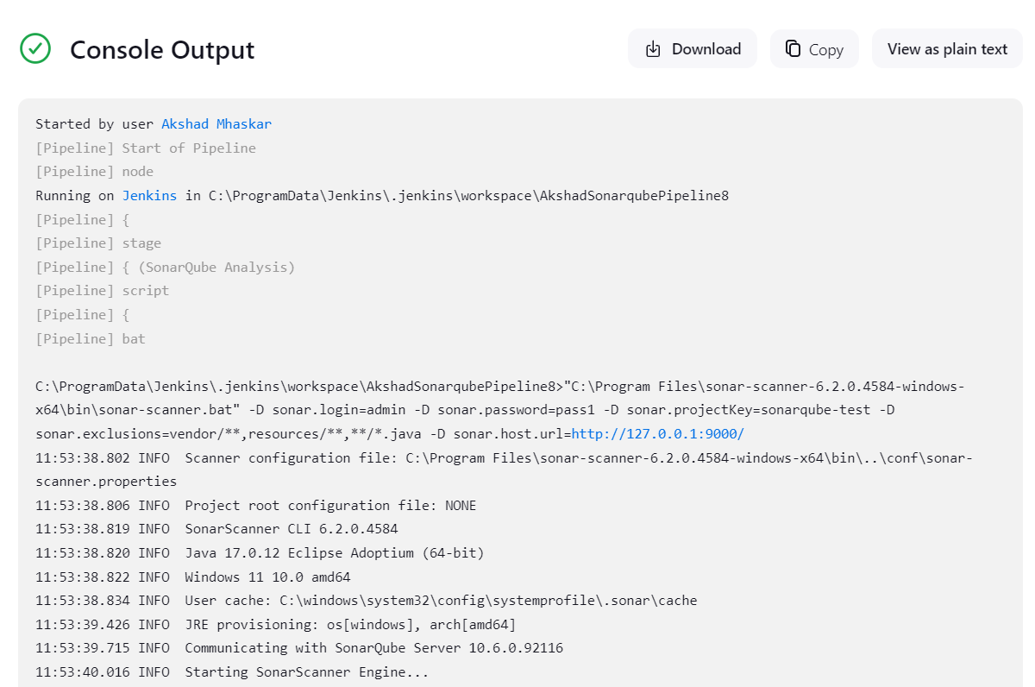

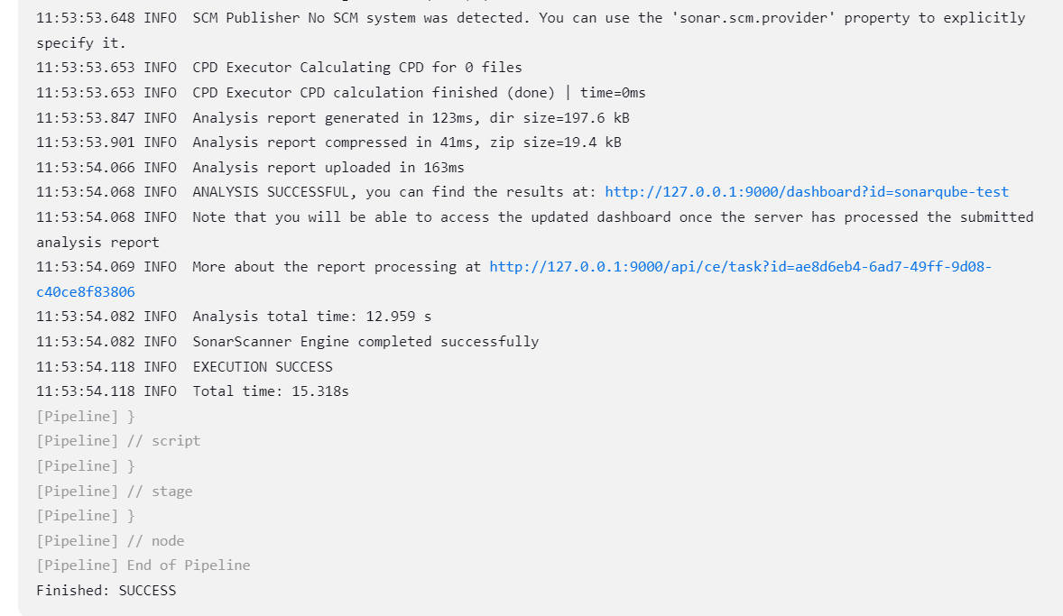

sonarqube:

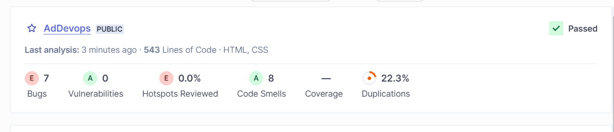

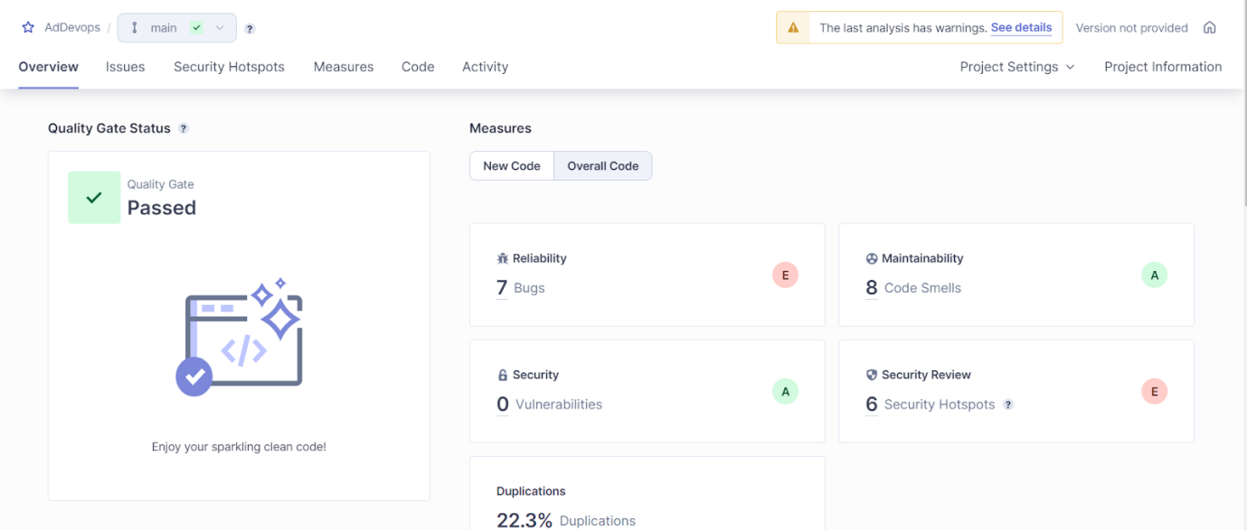

**Reliability:**

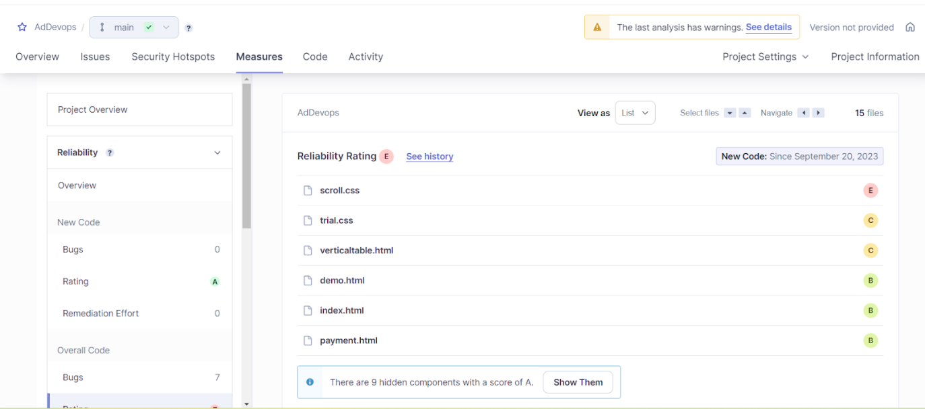

**Bugs:**

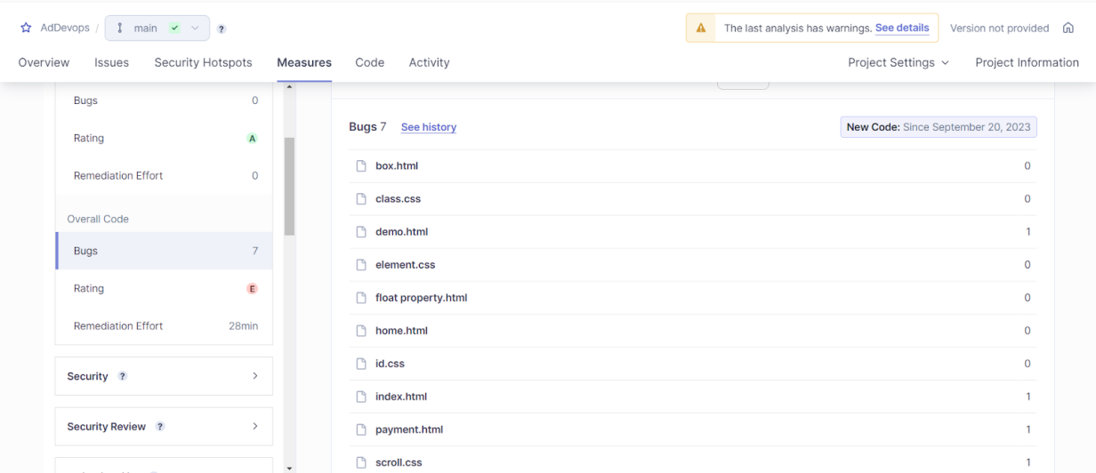

**Maintanaibility:**

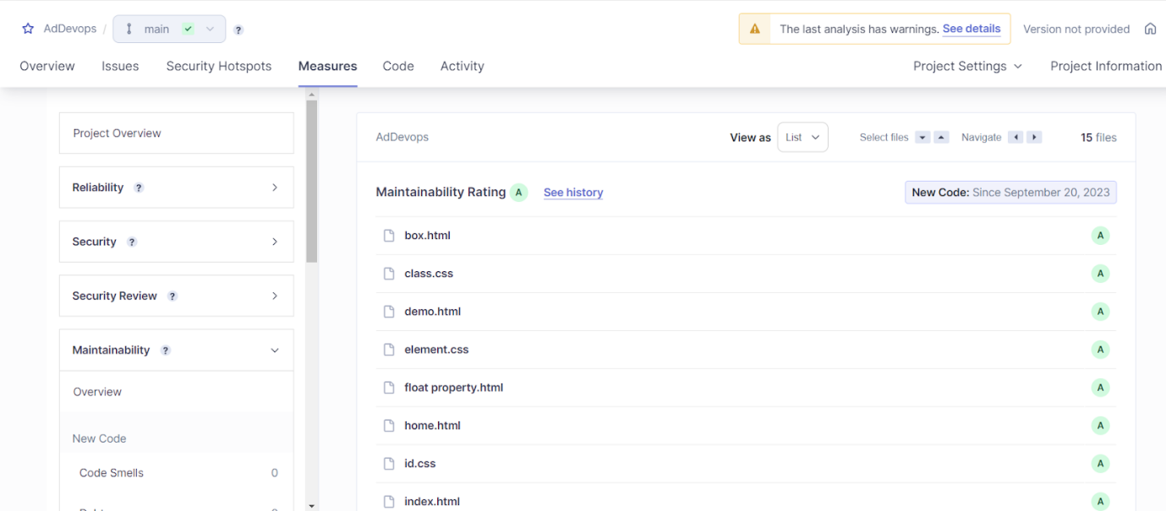

**Security:**

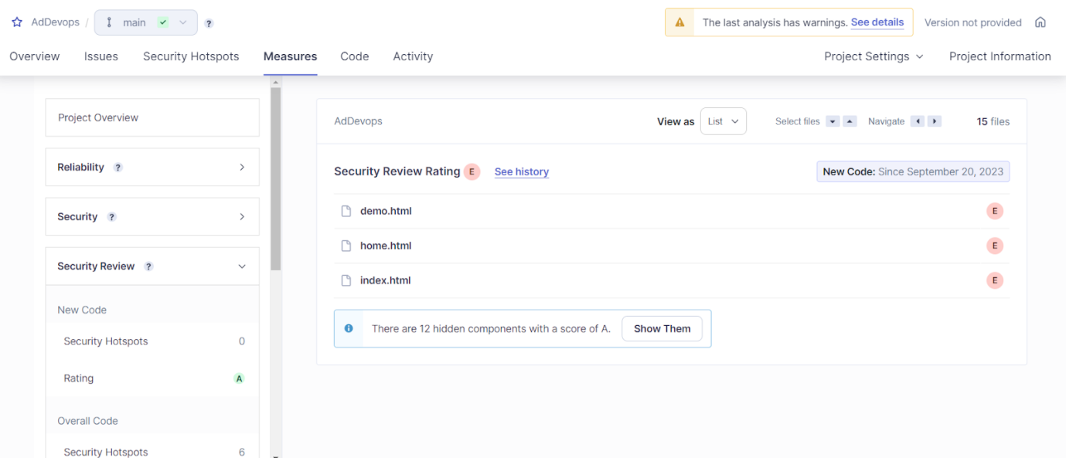

**Duplications:**

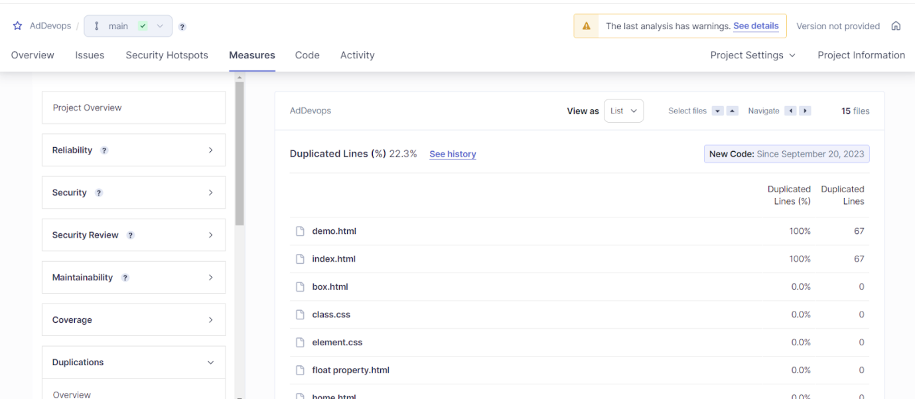

**Cyclomatic complexity:**

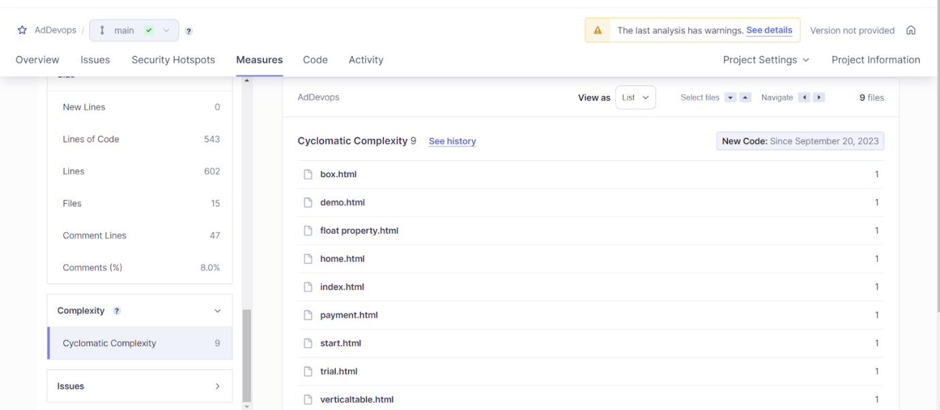

**Activity:**

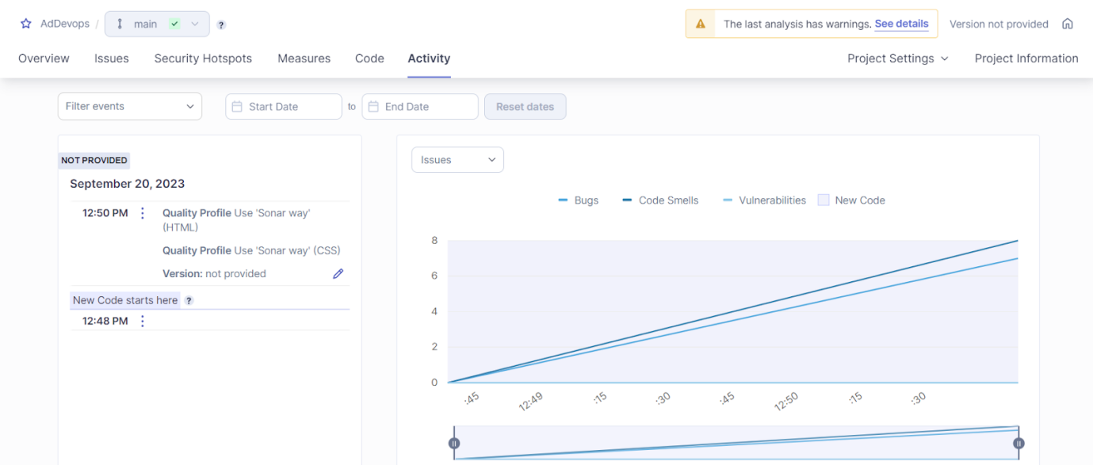

**Conclusion:** Thus, we have successfully integrated Jenkins with SonarQube.